Paper Title
Author’s Full Name^{1, *}, Author’s Full Name^{1, 2}
¹Department/Faculty, University, City, Country
²Department, Institute/Organization, City, Country
Email address:
email1@authorname.com (author name1), email2@authorname.com (author name2)
*Corresponding author
To cite this article:
Author’s Name. Paper Title. Journal Title. Vol. x, No. x, 2023, pp. x-x. doi: 10.11648/j.xxx.xxxxxxxx.xx.
Received: MM DD, 2023; Accepted: MM DD, 2023; Published: MM DD, 2023

Abstract: An abstract is a short summary of your research paper, usually about a paragraph (200-400 words) long. A well-written abstract can let readers get the essence of your paper, prepare readers to follow the detailed information, analyses, and arguments in your full paper, and help readers remember the key points.
Keywords: Keyword1, Keyword2 … Keyword8

1. Introduction
This template, created in MS Word 2000/2007/2010 and saved as “Word 97-2000 & 6.0/95 – RTF” for the PC, provides authors with most of the formatting specifications needed for preparing electronic versions of their papers. All standard paper components have been specified for three reasons: (1) ease of use when formatting individual papers, (2) automatic compliance to electronic requirements that facilitate the concurrent or later production of electronic products, and (3) conformity of style throughout a journal publication. Margins, column widths, line spacing, and type styles are built-in; examples of the type styles are provided throughout this document. Some components, such as multi-leveled equations, graphics, and tables are not prescribed, although the various table text styles are provided. The formatter will need to create these components, incorporating the applicable criteria that follow.
2. Custom Title (SciencePG-Level1-Multiple-line)
2.1. SciencePG-Level2
First, confirm that you have the correct template for your paper size. This template has been tailored for output on the A4 paper size.
2.2. SciencePG-Level2
The template is used to format your paper and style the text. All margins, column widths, line spaces, and text fonts are prescribed; please do not alter them. You may note peculiarities. For example, the head margin in this template measures proportionately more than is customary. This measurement and others are deliberate, using specifications that anticipate your paper as one part of the entire publication, and not as an independent document. Please do not revise any of the current designations.
2.2.1. SciencePG-Level3
Before you begin to format your paper, first write and save the content as a separate text file. Keep your text and graphic files separate until after the text has been formatted and styled. Do not use hard tabs, and limit use of hard returns to only one return at the end of a paragraph. Do not add any kind of pagination anywhere in the paper. Do not number text heads-the template will do that for you.
2.2.2. Abbreviations (SciencePG-Level3)
Define abbreviations and acronyms the first time they are used in the text, even after they have been defined in the abstract. Abbreviations such as IEEE, SI, MKS, CGS, sc, dc, and rms do not have to be defined. Do not use abbreviations in the title or heads unless they are unavoidable.
2.2.3. Equations (SciencePG-Level3)
The equations are an exception to the prescribed specifications of this template. You will need to determine whether or not your equation should be typed using either the Times New Roman or the Symbol font (please no other font). To create multileveled equations, it may be necessary to treat the equation as a graphic and insert it into the text after your paper is styled.
Equation numbers, within parentheses, are to position flush right, as in (1), using a right tab stop. To make your equations more compact, you may use the solidus ( / ), the exp function, or appropriate exponents. Italicize Roman symbols for quantities and variables, but not Greek symbols. Use a long dash rather than a hyphen for a minus sign. Punctuate equations with commas or periods when they are part of a sentence, as in
X+Y=Z (1)
X₁-Y²=R* (2)
Note that the equation is centered using a center tab stop. Be sure that the symbols in your equation have been defined before or immediately following the equation. Use “(1)”, not “Eq. (1)” or “equation (1)”, except at the beginning of a sentence: “Equation (1) is . . .”
3. SciencePG-Level1
3.1. Figure (SciencePG-Level2)
Figure is as follows: Place figures and tables at the top and bottom of columns. Avoid placing them in the middle of columns. Large figures and tables may span across both columns. Figure captions should be below the figures; table heads should appear above the tables. Insert figures and tables after they are cited in the text. Use the “Figure 1”, even at the beginning of a sentence.
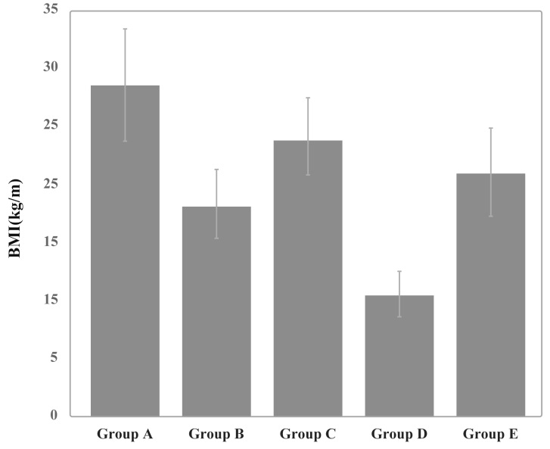
Figure 1. The caption of the figure.

3.2. Table (SciencePG-Level2)
Table is as follows: Use words rather than symbols or abbreviations when writing Figure axis labels to avoid confusing the reader. As an example, write the quantity “Magnetization”, or “Magnetization, M”, not just “M”.
Table 1. Table information.
Column1 | Column2
Row1* | Row1
Row2 | Row2
Row3 | Row3
Row4 | Row4
Row5 | Row5
Row6 | Row6
Row7 | Row7
* The example for this table.
3.3. In-text citations (SciencePG-Level2)
The template will number citations consecutively within brackets [1]. The sentence punctuation follows the bracket [2]. Refer simply to the reference number, as in [3]—do not use “Ref. [3]” or “reference [3]” except at the beginning of a sentence: “Reference [3] was the first . . .”
Number footnotes separately in superscripts. Place the actual footnote at the bottom of the column in which it was cited. Do not put footnotes in the reference list. Use letters for table footnotes.
Unless there are six authors or more give all authors' names; do not use “et al.”. Papers that have not been published, even if they have been submitted for publication, should be cited as “unpublished” [4-8]. Papers that have been accepted for publication should be cited as “in press” [9-12]. Capitalize only the first word in a paper title, except for proper nouns and element symbols.
For papers published in translation journals, please give the English citation first, followed by the original foreign-language citation [13-15].
4. Conclusion
After the text edit has been completed, the paper is ready for the template. Duplicate the template file by using the Save As command, and use the naming convention prescribed by your conference for the name of your paper. In this newly created file, highlight all of the contents and import your prepared text file. You are now ready to style your paper; use the scroll down window on the left of the MS Word Formatting toolbar.
Acknowledgements
You as the author are free to decide whether to include acknowledgments or not. Usually, the acknowledgments section includes the names of people who in some way contributed to the work, but do not fit the criteria to be listed as the authors. This section of your manuscript can also include information about funding sources.

References
- Hajnal Gabriela Illes, Anca Lupu,Bouchra Loutfi, Catherine Hoskovec, Jean Marc Rogero ,Laurent Delbast... & Damien Mondon. (2022). Efficacy and Safety of Dalbavancin Monotherapy as Salvage Treatment for Bone and Joint Infection. Clinical Medicine Research (3). doi: 10.11648/J.CMR.20221103.16.
- Xiongshuang Su, Cheng Chen,Jia Li,Shun Lu & Guihua Xu. (2022). Effect of Polypropylene Microplastics Concentration on Wastewater Denitrification. Science Journal of Chemistry (3). doi: 10.11648/J.SJC.20221003.11.
- Nuha Abdul Fattah & Hock Chuan Lim. (2022). Investigation on the Effectiveness of E-Leadership Styles and Skills in E-Business. American Journal of Computer Science and Technology (2). doi:10.11648/J.AJCST.20220502.12.
- Nabeeha Tashkandi, Laura Taylor, Litaba Efraim Kolobe, Sharon Chellan & Loh Cheng Cheng. (2022). Optimizing Post-Surgical Pain Management in Adult Surgical Patients: Effects of Training Interventions on Surgical Nurses’ Knowledge. American Journal of Nursing Science (2). doi: 10.11648/J.AJNS.20221102.14.
- Yoshito Shuto.(2022).Bending Induced Temperature Increases in Double-Clad Fibers for High-Power Fiber Lasers. Journal of Electrical and Electronic Engineering (2). doi: 10.11648/J.JEEE.20221002.14.
- Guomin Yang,Yanling Yao & Na Li.(2022).Knowledge, Attitudes and Practices (KAP) Related to the Coronavirus Disease 2019 (COVID-19) in a Village in Southern China: A Cross-sectional Survey. World Journal of Public Health (1). doi: 10.11648/J.WJPH.20220701.14.
- Hsin Jen Tsai & Fu Kuei Chang. (2022). Triclosan in Influents and Effluents from Sewage Treatment Plants Using Chlorine and UV Disinfection. American Journal of Environmental Science and Engineering (1). doi: 10.11648/J.AJESE.20220601.20.
- Jaber Abdulwahab Asiri,Sami Ahmed Kulaybi,Fatimah Ahmed Daghas & Ali Ibrahim Aamry.(2022).SPECT Ioflupane123I (DaTscan), 99mTc (TRODAT) and Ioflupane with Myocardial Scintigraphy 123I (MIBG) for Diagnosis of Parkinson’s Disease. Clinical Medicine Research (1). doi: 10.11648/J.CMR.20221101.12.
- Mahdi Darvish & Abdellah Ajji.(2022).Synergistic Antimicrobial Activities of Limonene with Mineral Carriers in LDPE Films for Active Packaging Application. Science Journal of Chemistry (2). doi:10.11648/J.SJC.20221002.11.
- Wang Shun Shen Peter,Wang Yin Tien,Chao Chong Lii, Yang Wei Bin, Wu Chyan Chyi & Lee Tzung Hang. (2022). Thermal Design of an MCM with the Implanted Temperature Sensor. Journal of Electrical and Electronic Engineering (2). doi: 10.11648/J.JEEE.20221002.11.
- Stelios C. A. Thomopoulos, Panagiotis Tsimpiridis,Eleni Ino Theodorou, Christos Maroglou, Efstathios Georgiou & Christiana Christopoulou. (2022). COSMOS: An Innovative, Graph-based Application for the Relational Presentation and Visualization of Greek Mythology and the Associated Art. American Journal of Computer Science and Technology (1). doi: 10.11648/J.AJCST.20220501.12.
- Zhe Luo, Ju Zhou & Yu e Huang. (2022). Effect of PDCA Evidence-Based Nursing Practice on Arterial Blood Gas Analysis in the Respiratory Department. American Journal of Nursing Science (1). doi: 10.11648/J.AJNS.20221101.15.
- Bo Chen, Junchao Cui, Qi Wang, Bo Zhang & Xinyi Wang. (2022). Evaluation of Water Isolation Capability of Coal Floor Rocks Based on ArcGIS Vulnerability Index Method. Earth Sciences (1). doi: 10.11648/J.EARTH.20221101.12.
- Daming Li. (2022). The Calculation of Force in Lattice Quantum Chromodynamics. American Journal of Physics and Applications (1). doi: 10.11648/J.AJPA.20221001.12.
- Victor Tringali, Matthew Fritts, Joseph Giandonato, Madeline Luehr, Caroline Reilly, Jenna Moody & Chad Aldridge. (2022). The Relationship of Workplace Health Climate and Participation in an Employee Wellness Program. American Journal of Health Research (1). doi: 10.11648/J.AJHR.20221001.13.

